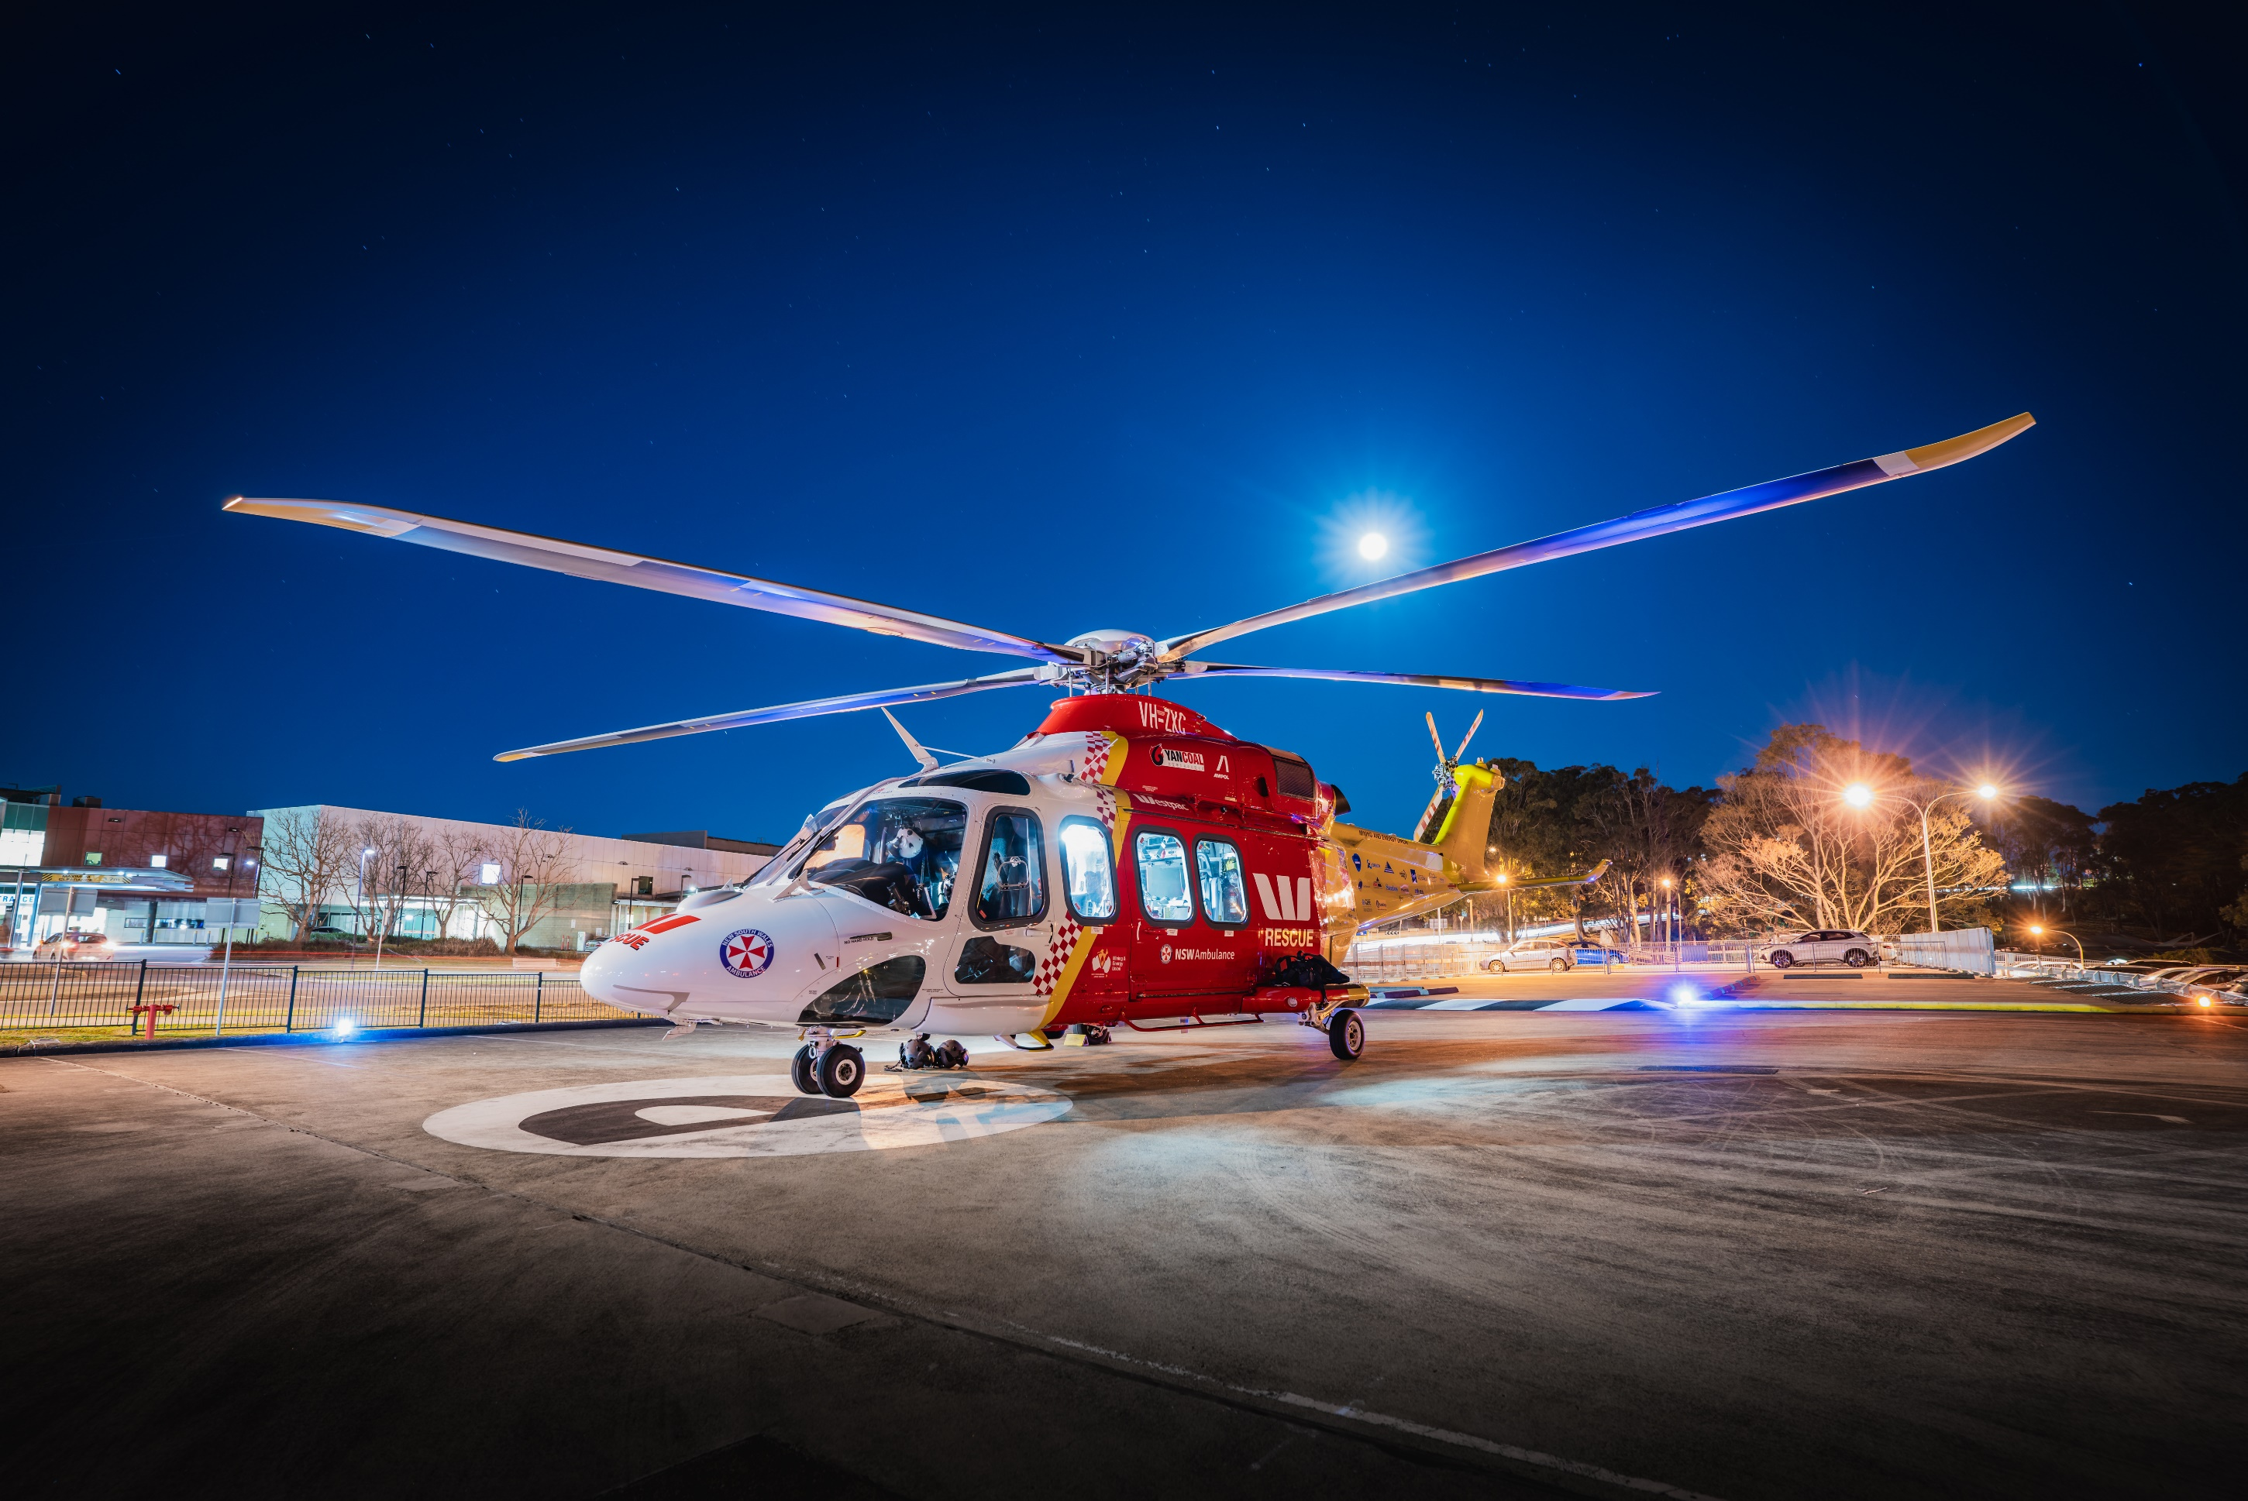

**Donations in lieu of flowers can be made online via the QR code in support of our local Westpac Rescue Helicopter Service…*Thank You***

**In Loving Memory of**

Bob McIntyre